# 

# FHEA Queen’s Merit Award Registration Form

Welcome to the Professional Recognition Scheme at Queen’s University Belfast leading to Fellowship of the Higher Education Academy (HEA). Your Line Manager, Head of School or PhD Supervisor (if applicable) should be cc’d and submitted to [qma@qub.ac.uk](mailto:qma@qub.ac.uk). The process is supported by a Canvas course.

In order to express your interest to apply for QMA, please send this completed form to the email address [qma@qub.ac.uk](mailto:qma@qub.ac.uk)

The purpose of this form is to allow you to provide a brief overview of your higher education career and your teaching and/or supporting learning roles and responsibilities to date. Before you submit this registration form you should complete the [Advance HE decision tool](https://www.advance-he.ac.uk/form/fellowship-decision-tool), to ensure you are aiming for the right category of Fellowship for you.

You may also wish to talk to your Line Manager, Head of School or PhD Supervisor to gain advice and/or contact the QMA Programme Lead if you have any questions.

**QMA Programme Lead:** Karen Fraser (qma@qub.ac.uk), 5865

**QMA Administrator:** Julio Carreño (qma@qub.ac.uk), 5845

# Section A – Personal and Factual Details

|  |  |  |  |  |
| --- | --- | --- | --- | --- |
| **Personal Details** | | | | |
| Title | |  | | |
| First Name | |  | | |
| Surname | |  | | |
| Job role | |  | | |
| Contact email | |  | | |
| School/Department/Institute | |  | | |
| Line Manager, Head of School or PhD Supervisor | | (enter details if applicable) | | |
| **Intended Submission Date for Application** | | | | |
| **Please indicate here which month and year you are intending to submit your application** | | | | | |
| Eg. July 2026 | | | | |
| **Please indicate what format you will submit your application in**  Please tick one | | | | |
| Written |  | | Recorded Presentation |  |

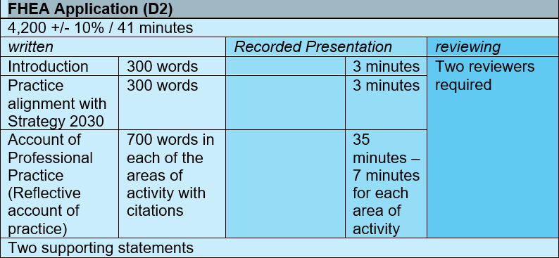

# Section B – Teaching and/or Supporting Learning Roles and Responsibilities

In this section please briefly outline your principal teaching and/or supporting learning roles and responsibilities within your current job role at Queen’s, and then more broadly over the last 3 years (if applicable). Roles and responsibilities listed need to be relevant to the category of fellowship you are applying for.

|  |  |  |
| --- | --- | --- |
| **Current Teaching and/or Supporting Learning Roles and Responsibilities at Queen’s in the last two years** | **From** | **To** |
|  |  |  |
|  |  |  |

# Section C – Referees and Advocates

Please provide the name of your referees for Fellow, (download the Guidance for applicants on the [QMA Website](http://www.qub.ac.uk/directorates/AcademicStudentAffairs/CentreforEducationalDevelopment/CoursesEventsProfessionalRecognition/HEA/) for advice on choosing referees/advocates and other details specific to each fellowship category).

|  |  |
| --- | --- |
| **Referee /Advocate 1** | |
| **Name** |  |
| **Fellowship level** |  |
| **Job Position** |  |
| **Email** |  |

|  |  |
| --- | --- |
| **Referee /Advocate 2** | |
| **Name** |  |
| **Fellowship level** |  |
| **Job Position** |  |
| **Email** |  |

# Section D – Sign and Date

Please complete, sign and date your registration form and forward it to your Line Manager, Head of School or PhD Supervisor for endorsing and signing. We can also accept signatures drawn electronically. We can also accept the application sent via email with no signatures as long as the relevant Line Manager/Head of School/PhD Supervisor has been copied in. Please send your completed form to [qma@qub.ac.uk](mailto:qma@qub.ac.uk); you will receive notice of its receipt. Once you are registered for the QMA, you will be sent an email inviting you to sign up for an induction workshop and providing further instructions.

**Date:**

**Signed by Applicant:**

**Line Manager/Head of School/PhD Supervisor cc’d.**